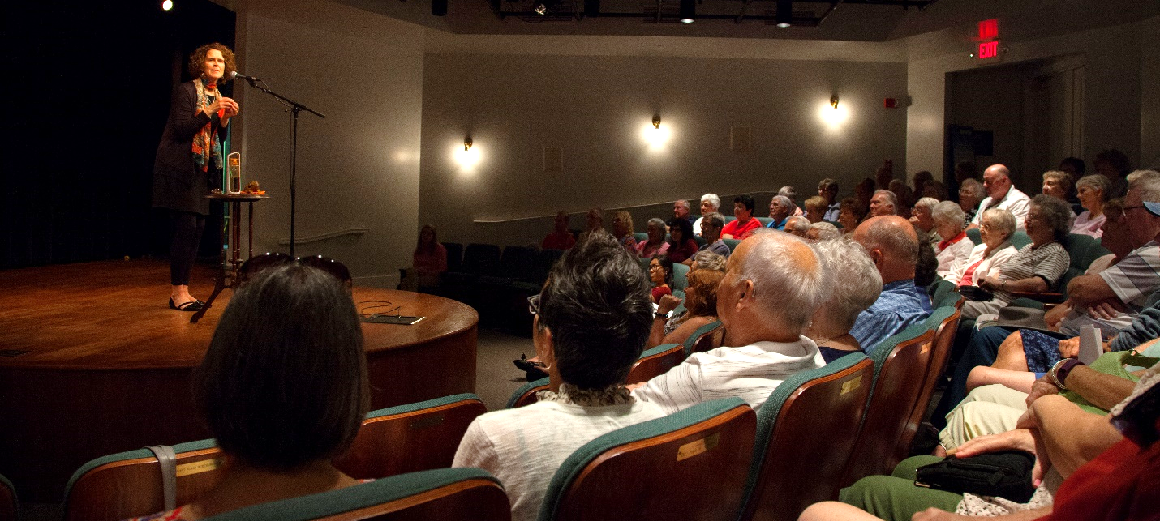

Storytelling Live! the International Storytelling Center’s renowned Teller-in-Residence program, features a line-up of 26 nationally-known storytellers. Each week during May through October, a different artist appears at the Center Theater in live afternoon concerts. Workshops and evening and children’s concerts are also offered.

The Storytelling Live! performers represent the finest talent available in the world of storytelling—presented in Jonesborough, Tennessee the storytelling capital of the world.

Annual Program Accomplishments
- Contributes more than 7.6 million to the region’s economy
- Provides over 1,500 complimentary performances to underserved youth
- Hosts more than 12,000 audience members
- Features more than 30 artists
- Has made Jonesborough, Tennessee a tourist destination—“the storytelling capital of the world”
- Includes over 200 hours of live programming
- Enjoys national media coverage

Storytelling Live! Sponsorship Categories

Presenting Sponsor - $10,000

Opportunity to serve as the premier event sponsor. This sponsorship is exclusive and includes all gold season sponsor benefits, plus additional tailored benefits to meet your business needs; possibilities include additional rental opportunities, National Storytelling Festival tickets and benefits, private performances, and workshop opportunities.

Gold Season Sponsor - $5,000

Recognition
- Prominent position on the Storytelling Live! season brochure, distributed to 25,000 customers by mail and displayed at key business outlets, restaurants, and retail establishments in the Tri-cities region and beyond
- Acknowledgement in the Storytelling Live! event playbill, a program that is provided to each attendee at every performance―approximately 150 performances entertaining more than 12,000 guests
- Season signage displays located both inside and outside the event venue
- Acknowledgement in all news releases publicizing the Storytelling Live! season
- Feature articles about the current teller-in-residence appear weekly throughout the 26-week season in four area newspapers.
- News releases are distributed weekly throughout the season to additional Tri-Cities media, specifically entertainment-based publications.
- Recognition, including the sponsor’s logo, within the Storytelling Live! section of ISC’s website with a direct link to a business website. ISC’s website welcomes nearly 350,000 views per year.
- Recognition in e-marketing and social media messages promoting the season ― including a minimum of 8 e-mail marketing messages distributed to ISC’s e-mail database of nearly 10,000 contacts and frequent updates on Facebook, Twitter, and Instagram to almost 12,000 friends and followers
Ticketing
- Up to 52 complimentary tickets to be redeemed during the Storytelling Live! season
(Reservations required)
Facility Rental
- One complimentary rental use of the Mary B. Martin Storytelling Hall to entertain clients/employees during the year (some restrictions may apply)

Silver Season Sponsor - $2,500

Recognition
- Prominent position on the Storytelling Live! season brochure, distributed to 25,000 customers by mail and displayed at key business outlets, restaurants, and retail establishments in the Tri-cities region and beyond
- Acknowledgement in the Storytelling Live! event playbill, a program that is provided to each attendee at every performance―approximately 150 performances entertaining more than 12,000 guests
- Season signage displays located both inside and outside the event venue
- Acknowledgement in all news releases publicizing the Storytelling Live! season
- Feature articles about the current teller-in-residence appear weekly throughout the 26-week season in four area newspapers.
- News releases are distributed weekly throughout the season to additional Tri-Cities media, specifically entertainment-based publications.
- Recognition, including the sponsor’s logo, within the Storytelling Live! section of ISC’s website with a direct link to a business website. ISC’s website welcomes nearly 350,000 views per year.
- Recognition in e-marketing and social media messages promoting the season ― including eight e-mail marketing messages distributed to ISC’s e-mail database of nearly 10,000 contacts and frequent updates on Facebook, Twitter, and Instagram to almost 12,000 friends and followers
Ticketing
- Up to 26 complimentary tickets to be redeemed during the Storytelling Live! season
(Reservations required)

Bronze Season Sponsor - $1,000

Recognition
- Acknowledgement in the Storytelling Live! event playbill, a program that is provided to each attendee at every performance―approximately 150 performances entertaining over 12,000 guests
- Inclusion of company logo on Storytelling Live! season signage displays
- Season signage displays located both inside and outside the event venue
- Acknowledgement in all news releases publicizing the Storytelling Live! season
- Feature articles about the current teller-in-residence appear weekly throughout the 26-week season in four area newspapers.
- News releases are distributed weekly throughout the season to additional Tri-Cities media, specifically entertainment-based publications.
- Recognition within the Storytelling Live! section of ISC’s website with a direct link to your business website. ISC’s website welcomes nearly 350,000 views per year.
- Recognition in e-marketing and social media messages promoting the season ― including eight e-mail marketing messages distributed to ISC’s e-mail database of nearly 10,000 contacts and frequent updates on Facebook, Twitter, and Instagram to almost 12,000 friends and followers
Ticketing
- Up to 10 complimentary tickets to be redeemed during the current Storytelling Live! season
(Reservations required)

Children’s Storytelling/Outreach Series - $ 2,000

The Children’s Series sponsorship allows ISC to present special storytelling concerts for children and provide outreach storytelling activities to our region’s low-income and at-risk youth who may not have the opportunity to hear stories.

The Children’s Storytelling Concert Series features exceptional tellers during exciting Saturday morning programs that are created especially for kids. As an extension of our on-site programming for kids, our tellers in residence also perform for schools, libraries, non-profit agencies and institutions throughout the Tri-Cities Region to bring hundreds of stories into the lives of children. This sponsorship helps ISC to cover the full cost of the admission to any storytelling concert or outreach event for any financially disadvantaged child or youth.

Recognition
- Recognition in the Storytelling Live! season brochure as the Children’s Concert Series sponsor. The season brochure has a distribution of 25,000 by mail to our customers and displayed at key business outlets, restaurants and retail establishments in the Tri-cities region and beyond.
- Acknowledgement in the Storytelling Live! event playbill, a program that is provided to each attendee at every performance―approximately 150 performances entertaining more than 12,000 guests
- Inclusion of company logo on Storytelling Live! season signage displays as the Children’s Concert Series sponsor.
- Season signage displays located inside and outside the event venue
- Acknowledgement in all news releases related to the Children’s Concert Series
- Pre-show announcement at Children’s Storytelling Concerts and outreach events
- Recognition on the Children’s Storytelling Concert page, including the sponsor’s logo, within the Storytelling Live! section of ISC’s website with a direct link to business website. . ISC’s website welcomes nearly 350,000 views per year.
- Recognition in e-marketing and social media messages promoting the Children’s Storytelling Concert series to ISC’s e-mail database of nearly 10,000 contacts and frequent updates on Facebook, Twitter, and Instagram to almost 12,000 friends and followers
Ticketing
- Up to 20 complimentary tickets for to be redeemed during the Storytelling Live! season
Media and Marketing Stats
- Brochure distribution: 25,000 annually
- Email subscribers: 10,000
- Website visitors: 347,000 annually
- Social media impressions: 1.6 million annually

Inquiries
Angela White ∙ Communications Associate
800-952-8392 x230
angela@storytellingcenter.net

